**Objective Questions:**

1. **Does any table have missing values or duplicates? If yes, how would you handle it?**

**Ans:** Yes, there are missing values in the table and by checking the count of NULL values and replacing it with an appropriate word we can handle them.

I checked for duplicate values in the unique key (customer_id) in Customer table and found none. To cross check it, checked the total customer_ids as well and we can do this for all the other tables.

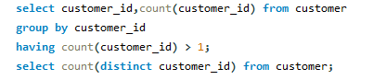



1. **Find the top-selling tracks and top artist in the USA and identify their most famous genres.**

**Ans:** The top-selling tracks and artist in the USA along with their famous genres are War Pigs, Cake and alternative respectively. In the following screen capture other top-selling tracks and artist are also mentioned.

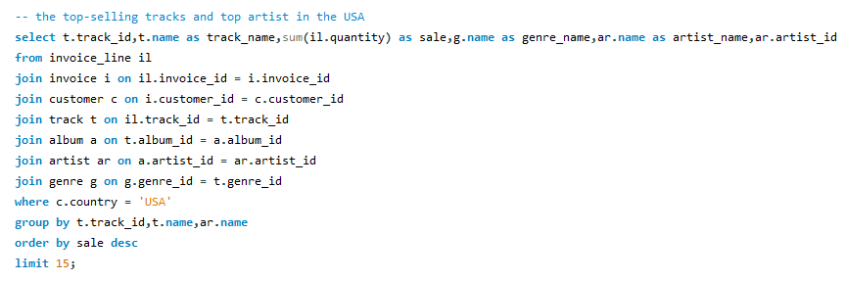

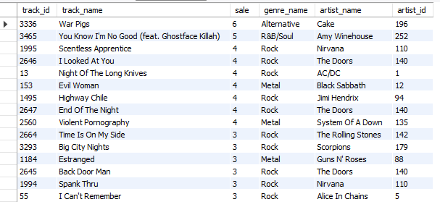

1. **What is the customer demographic breakdown (age, gender, location) of Chinook's customer base?**

**Ans:** In this data we are provided with the location only hence we will be focusing on the location specific customer breakdown. I have attached screen capture firstly, the countrywise breakdown and after that city and statewise breakdown.  
We can see that the top 3 countries who make the most of the Chinook’s customer base are Czech Republic, Ireland and India.

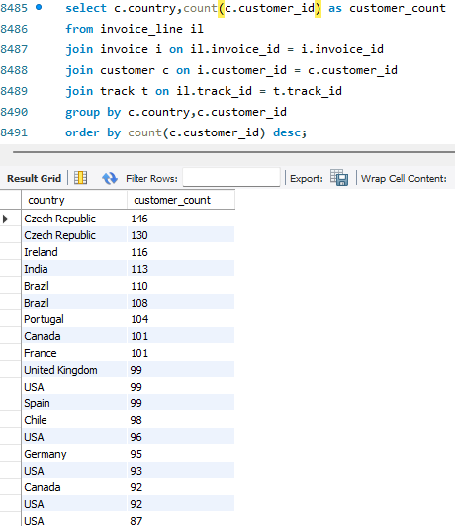

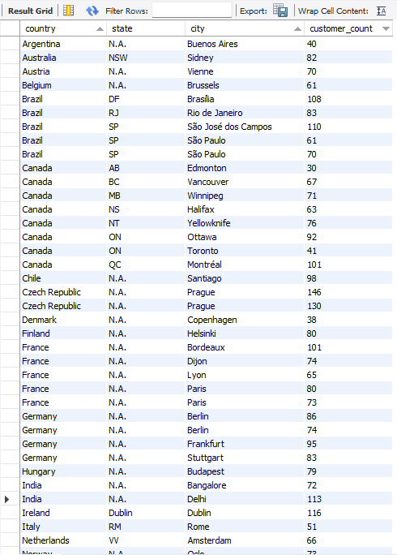

1. **Calculate the total revenue and number of invoices for each country, state, and city.**

**Ans:** Following are the details of the total revenue and number of invoices for each country, state, and city.

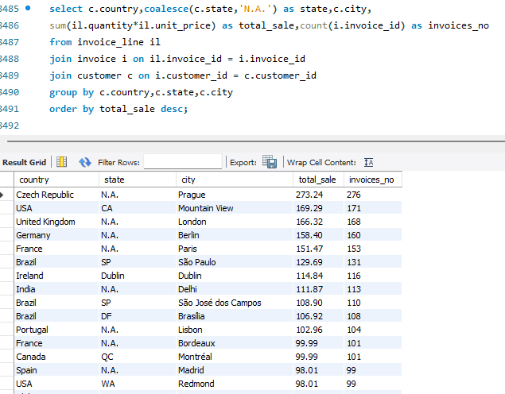

1. **Find the top 5 customers by total revenue in each country.**

**Ans:** I have mentioned below the top 5 customers by total revenue in each country.

Ans: 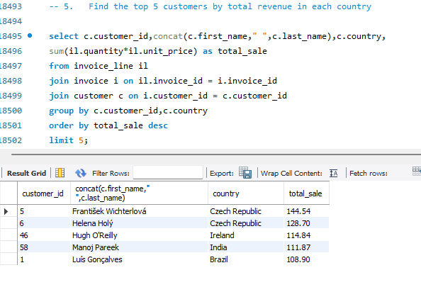

1. **Identify the top-selling track for each customer.  
   Ans:** Following are the top-selling track for each customer.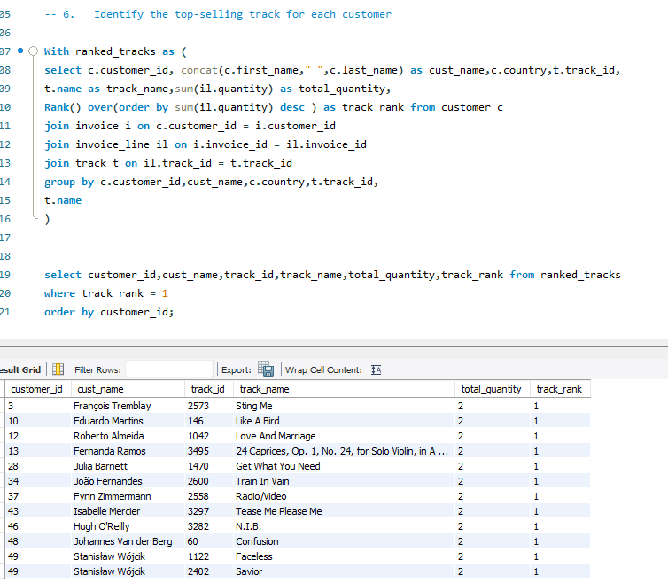
2. **Are there any patterns or trends in customer purchasing behaviour (e.g., frequency of purchases, preferred payment methods, average order value)?**

**Ans**- In the SQL file, I have written queries for –

1. Frequency of Purchases
2. Calculate the average order value for each customer
3. Calculate the total revenue generated by each customer
4. Identify the preferred purchase periods

On the basis of this I can see that when its Thursday and Friday, the purchase go slightly higher. Whereas there is no such pattern for the frequency of purchases.

**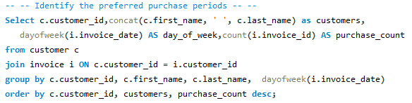 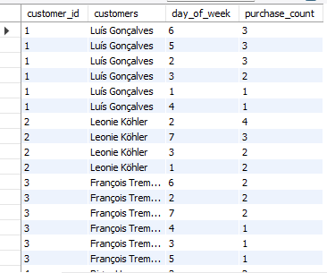  
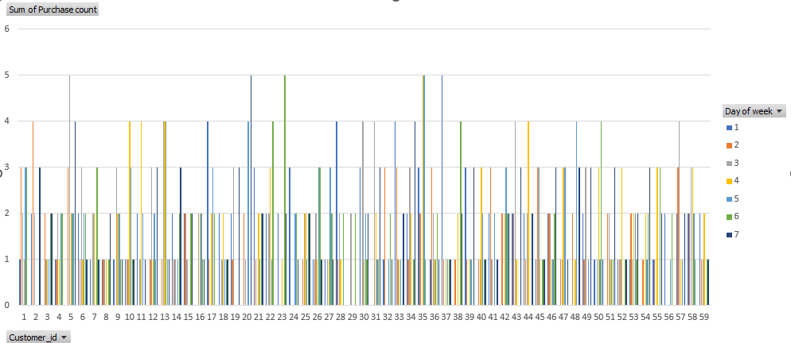**

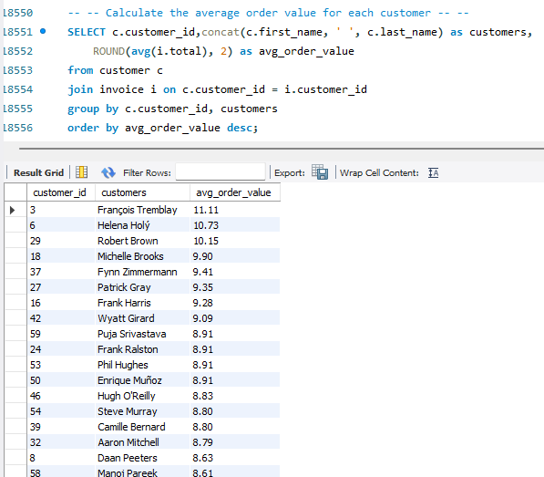

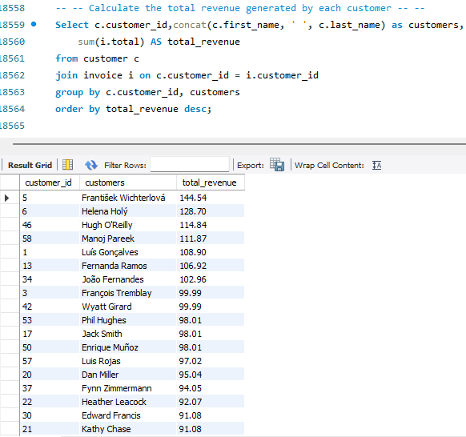

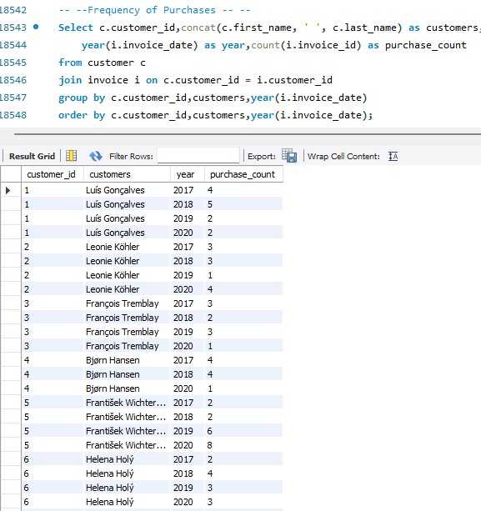

1. **What is the customer churn rate?**

**Ans-** The customer churn rate is 1.6949.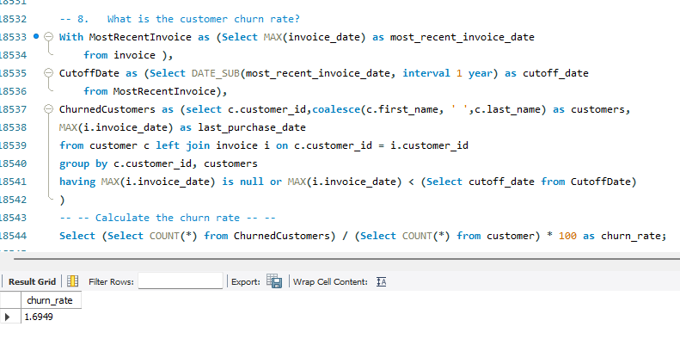

1. **Calculate the percentage of total sales contributed by each genre in the USA and identify the best-selling genres and artists.**

**Ans-** Following is the percentage of total sales.

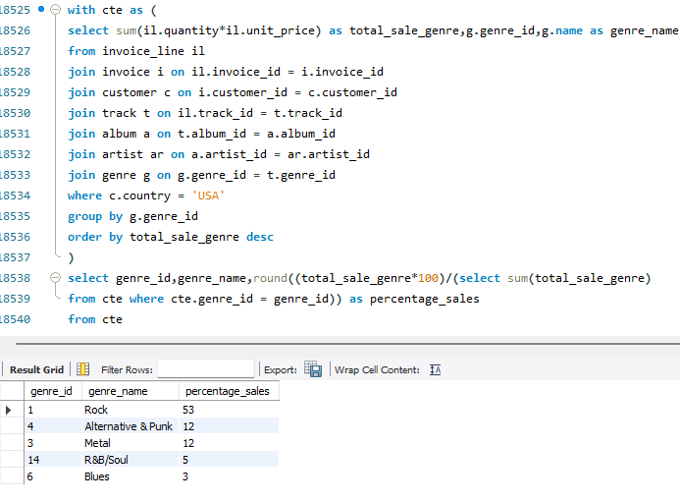

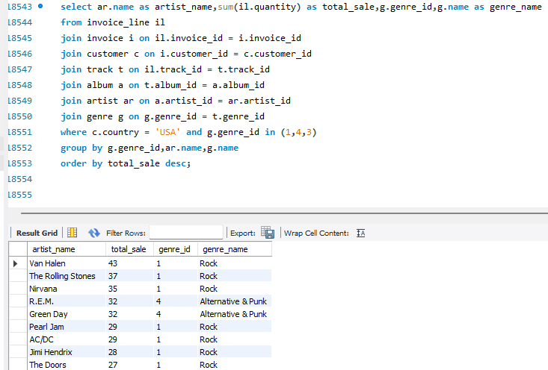

1. **Find customers who have purchased tracks from at least 3 different genres**

**Ans-** 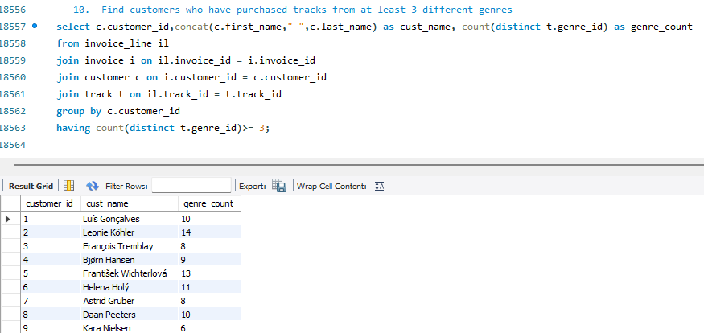

1. **Rank genres based on their sales performance in the USA.**

**Ans-** 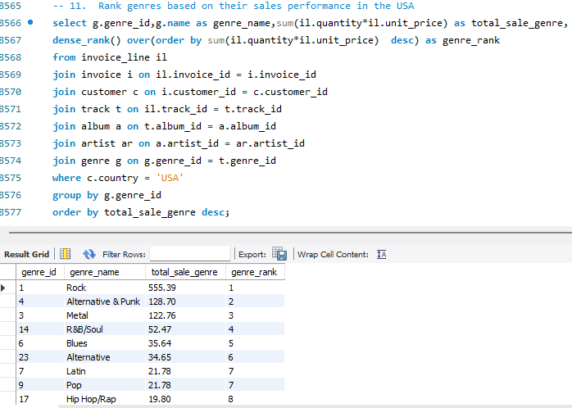

1. **Identify customers who have not made a purchase in the last 3 months.**

**Ans-**

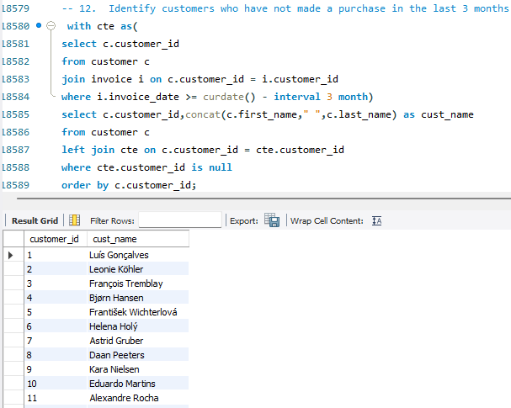

**Subjective Questions-**

1. **Recommend the three albums from the new record label that should be prioritised for advertising and promotion in the USA based on genre sales analysis.**

**Ans-**

* **Reference-** For the query, do check the SQL file in that under the Subjective questions (Line - 18658) the query is written for Question 1.
* **Approach-** 1. Consider the total sales in the USA with their respective albumnames. For that the sum of quantity in to unit price is to be done.

2. To find this, the joining of tables is to be done which can be checked in the screen capture for finding the different columns/values from different tables.  
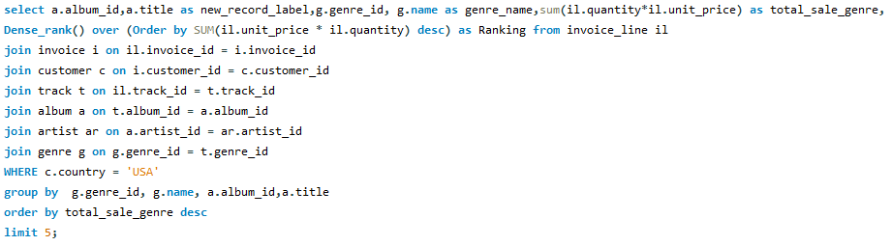

3. I have created a new column named new_record_label which is asked in the question.

4. I have used Dense_rank to rank the different genre in the USA.  
 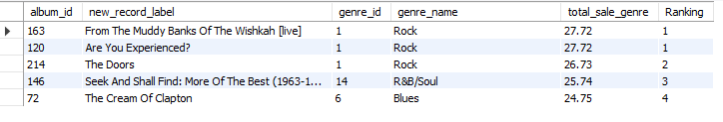

* **Key Insights-** The output shows that the genre Rock,R&B/Soul and Blues are the most sold genre in the USA. So, we can recommend the albums associated with those genres to prioritise for advertising and promotion in the USA based on genre sales analysis.

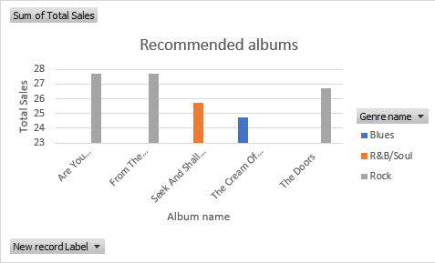

1. **Determine the top-selling genres in countries other than the USA and identify any commonalities or differences.**

**Ans-**

* **Reference-** For the query, do check the SQL file in that under the Subjective questions (Line - 18658) the query is written for Question 2.
* **Approach-** 1. Consider the total sales in the countries other than USA with their respective genrenames. For that the sum of quantity in to unit price is to be done.

2. To find this, the joining of tables is to be done which can be checked in the screen capture.   
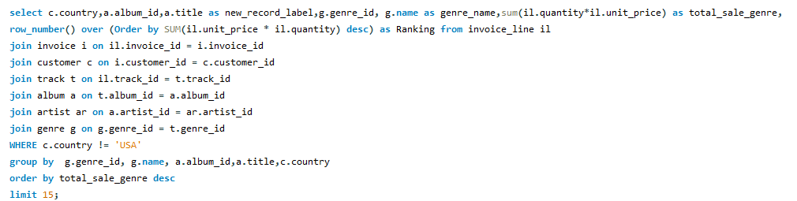

3. After running this query, we can see that Brazil, France and Canada are the 3 countries where the genre sales are high.

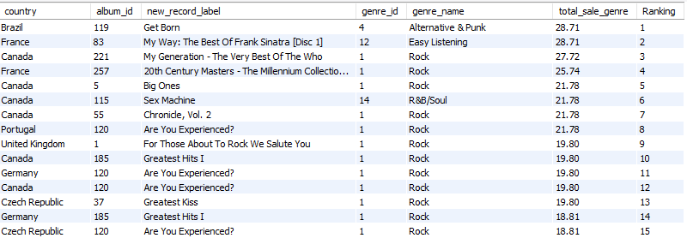

* **Insights-** With reference to the above output we can see that in all the countries the genre Rock has good sales, this genre should be recommended for marketing purposes as it is a choice of customers all over the world. People are able to relate with the albums made under this genre by various artists. But considering the genres Alternative & Punk and Easy Listening which has the highest sales in Brazil and France, these can also be recommended in both the countries.

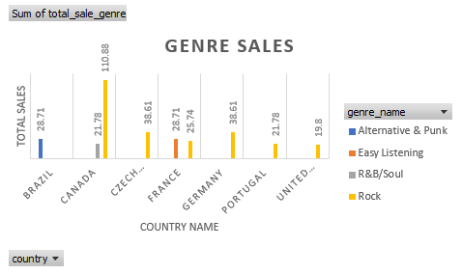

1. **Customer Purchasing Behaviour Analysis: How do the purchasing habits (frequency, basket size, spending amount) of long-term customers differ from those of new customers? What insights can these patterns provide about customer loyalty and retention strategies?**

**Ans-**

* **Reference-** For the query, do check the SQL file in that under the Subjective questions (Line - 18658) the query is written for Question 3.
* **Approach-**1. We found the purchasing habits of the customers by finding whether the customer is a new customer or a long-term customer.2. We searched for the customer id with their purchase frequency, average basket size, total spent and average spending including the case statement for anew customer or a long-term customer.  
  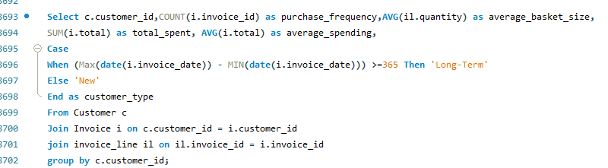  
  3. In the given data provided, the long-term customer would be when the difference between the first purchase date and last purchase date is greater than or equal to 365 days.   
  4. The output shows that there are long-term customers only in this data. 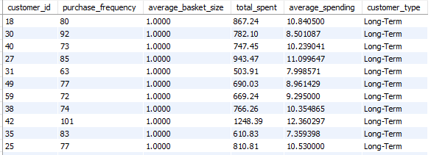  
  5. Most of the orders are from the USA, Canada and Brazil  
  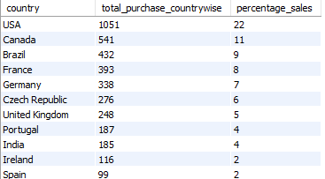
* **Insights-** The customers from the countries where the sales are high are loyal customers and with low sales needs some retention strategies. We can ask them for their choice of favourite genre, album and artist for providing discounts which will increase the sales. Even the customers who make frequent purchases should be given regular rewards by arranging online contests, offline concerts which keeps them happy about music.   
  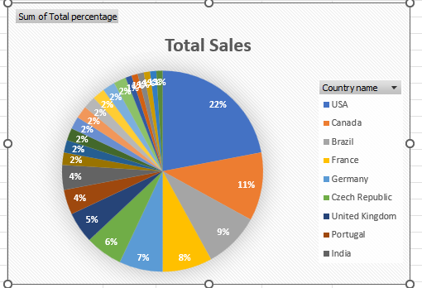

1. **Product Affinity Analysis: Which music genres, artists, or albums are frequently purchased together by customers? How can this information guide product recommendations and cross-selling initiatives?  
   Ans-**

* **Reference-** For the query, do check the SQL file in that under the Subjective questions (Line - 18658) the query is written for Question 4.
* **Approach-**1. We will first find the frequently purchased genres, artists, and albums to see what is the choice of the customers across the world.  
  2. So, we will be combining multiple tables for the same**.  
  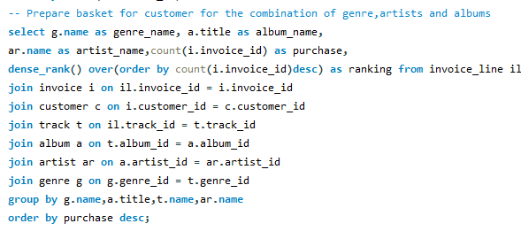**3. The combo of the bestselling genre, artist and albums are as follows-  
  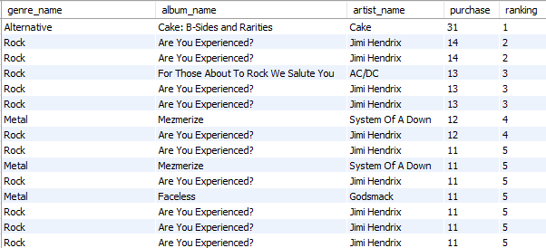
* **Insights-** We can come to a conclusion that if any customer adds any genre, album name or artist name from the above list then we can recommend them the entire combo which will ease their purchase. Such cross-selling options adds to the sales in turn saving the time of the customer and creating more options for them to place an order. We are helping them take informed decisions and not dropping off from the check-out page.

1. **Regional Market Analysis: Do customer purchasing behaviours and churn rates vary across different geographic regions or store locations? How might these correlate with local demographic or economic factors?  
   Ans-**   
   **Reference-** For the query, do check the SQL file in that under the Subjective questions (Line - 18658) the query is written for Question 5.  
   **Approach-** 1. We will try to find the churn rate for individual countries here I have shown the churn rate for USA.  
   2. Considering the given data the churn rate shows same for all the countries because the duration between the first and last purchase for all the customers is almost same. 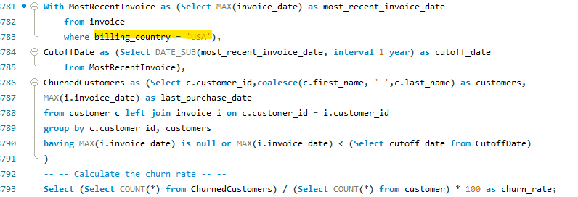  
   3. The churn rate is 1.6949 for almost all the countries whereas such is not the case in the real-time.

**Insights-** If we consider the churn rate that is the rate at which customers stop doing business with a company over a given period of time, it does differ for different geographic regions or store locations. Because the purchasing time, occasion, feeling, mood and location differs. It is possible that whenever the main festivals, vacations or any special event of a particular country and in that a particular state the sales will increase and whenever the seasons are over, we can see a dip in sales.  
So, to keep the sales moderate throughout the year we will have to take initiatives to engage the customers. Keep a track on the purchase behaviour throughout the year by a quarterly sales analysis. Our marketing strategy should keep on adding new recommendations to them every quarter, quizzes, QnA sessions, online events, celebrity podcasts or chit chat.

1. **Customer Risk Profiling: Based on customer profiles (age, gender, location, purchase history), which customer segments are more likely to churn or pose a higher risk of reduced spending? What factors contribute to this risk?**  
   **Ans-**

* **Reference-** For the query, do check the SQL file in that under the Subjective questions (Line - 18658) the query is written for Question 6.
* **Approach-**1. In a few questions solved about we have seen the customer purchase behaviour based on their location, number of purchases, so this time lets check the customer profiles based on the companies that they belong to.   
  2. The mention of the company shows if they are working on not, we can find out what our majority of customers do. Do they make the purchase for themselves or for their family members/spouse.  
  3. This approach can help us give them customized combo plans with a slightly lower price if they are with us for the long term.  
  4. For New customers we can ask them basic questions at the time of making their profile.  
  5. The profession of the customer or the company they work in tells a lot about their personality, decision making power and interests towards music.  
  6. There is no point in making creative marketing strategies or retention strategies for customers who don’t have time to listen to the music.  
  7. We found out sales based on the company they belong to. 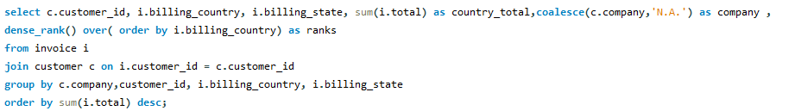   
  8. 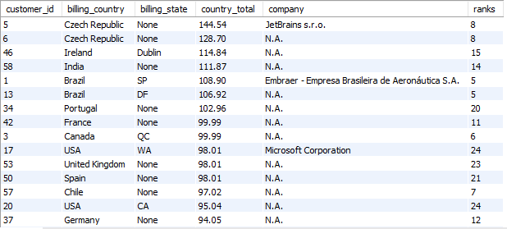

**Insights-** We found out that most of our customers around the world are either freelancer, business persons, homemakers, artists and a few who are salaried in that particular country.  
There are chances that a few customers might stop spending more depending upon their earnings. We can say that people with inconsistent earnings can have or cannot have frequent purchase, whereas artists will continue to buy no matter what as it’s a therapy cum study for them. The country-wise churn rate can change depending upon how well the positioning of the brand is with the quality customer service and marketing with pricing.

1. **Customer Lifetime Value Modelling: How can you leverage customer data (tenure, purchase history, engagement) to predict the lifetime value of different customer segments? This could inform targeted marketing and loyalty program strategies. Can you observe any common characteristics or purchase patterns among customers who have stopped purchasing?  
   Ans-   
   Reference-** For the query, do check the SQL file in that under the Subjective questions (Line - 18658) the query is written for Question 7.  
   **Approach-**1. Analyse the different types of customer behaviour by their total spend an average spend.  
   2. We will get the customer details for the same with a query which has common table expressions.  
   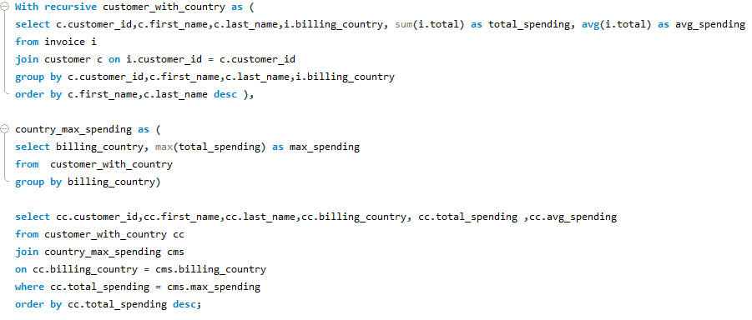  
   3. We have found out customer with country and country maximum spending.  
   4. So, the output tells us about the differentiation in the customers considering the above parameters.  
   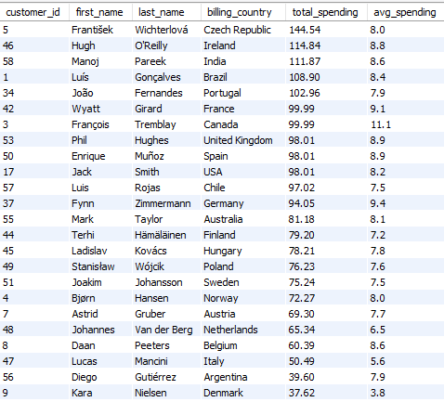  
    **Insights-** We see there are High Lifetime Value Customers and Low Lifetime Value Customers. Also observed the purchase patterns like Higher engagement has higher retention and lower engagement has lower retention. Repeated order is placed by High Lifetime Value Customers, they don’t get churned easily. Whereas the Low Lifetime Value Customers get churned easily.  
   These customers give a nice analysis for implementing marketing strategies. It might also help us know if any improvement is to be done for the growth of a particular city.  
   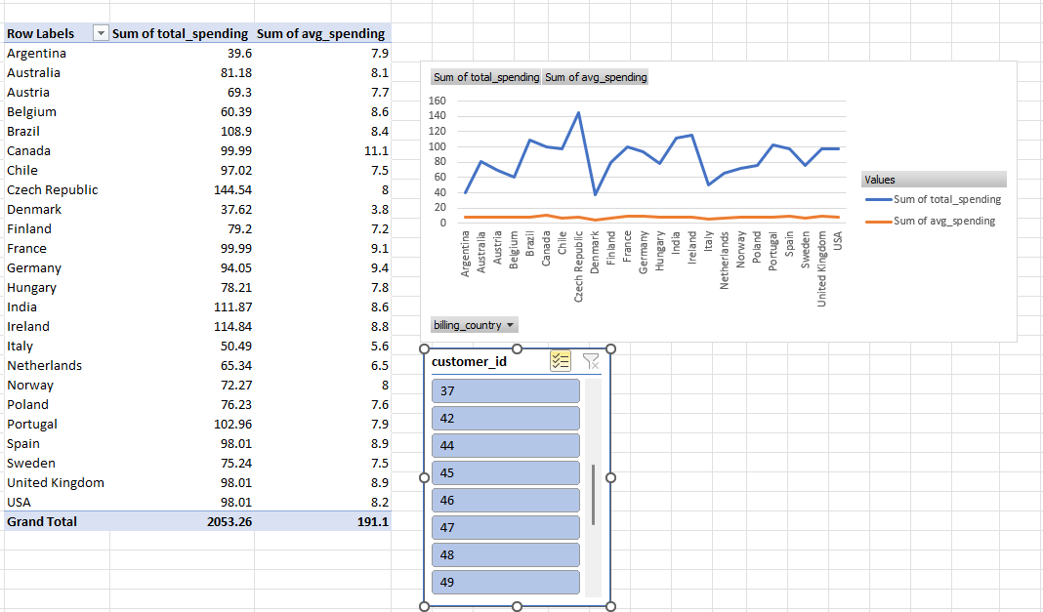
2. **If data on promotional campaigns (discounts, events, email marketing) is available, how could you measure their impact on customer acquisition, retention, and overall sales?**  
   **Ans-** **Approach-**1.Considering the existing data, we have already seen the sales considering the customer locations, genres, artists and companies. So, for example we can do email marketing on the 15th august in India then find out how many people purchased in a particular time frame.  
   What was the email opening rate and compare it with the purchase.  
     
   2. If we organise music events in particular cities where the artists are the residents of then we can correlate what is the purchase percentage in that city before the music events and between start date and end date of the event.  
     
   3. We can take live feedbacks from the attendees telling them as our best customers will feature on our social media handle.  
     
   4. The awareness or instilment of the music can be done with such events.  
     
   5. We can create customised discounts based on the particular mass event happening in a country and check the sales from the start date and the end date of the discount.  
     
   6. If we come across even a slight increase in the sales then we should keep on repeating such events, discounts or marketing strategies to acquire more customers considering the years into the business.  
     
   7. We can hire influencers to talk about the company, the amazing UI and customer centric approach.  
     
   8. In such a way we can retain a few clients who might have lost interest due to multiple reasons.
3. **How would you approach this problem, if the objective and subjective questions weren't given?**

**Ans-** If no predefined questions are given, I would always prefer a comparative analysis.  
The simplest approach is to check what all values are provided. What general assumptions can be made, as it’s related to business then we have to check the growth, profit, analyse sales and give marketing strategies to improve it which is the task of a Data Analyst. The role is to give insights based on the data.

**1. Data cleaning is the approach that is taught whenever we are given a data-**

* Check for missing values and duplicates.
* Clean data by imputing or removing incomplete records.

**2. Understanding the Data -**

* Identify entities and relationships with all the available tables e.g., Employee, Customer, Invoice etc in this case.

**3. Sales Performance Analysis**

* Analyse total sales, average order value, and top-selling tracks across time, geography, and customer segments.

**4. Customer Analysis**

* Analyse demographics and segment customers by purchase history.

**5. Market and Regional Analysis**

* Assess sales performance across regions and correlate with external factors like demographics.

**6. Product Affinity and Cross-Selling**

* Identify frequently purchased product combinations for cross-selling recommendations.

**7. Promotional Impact Analysis**

* Measure the impact of promotions on sales and customer behaviour.

**8. Strategic Insights and Recommendations**

* Identify growth opportunities, optimize pricing, and develop targeted marketing strategies.
* Determine key metrics like sales performance and customer demographics.

**9. Documentation and Reporting**

* Summarize findings with visualizations and provide report.

1. **How can you alter the "Albums" table to add a new column named "ReleaseYear" of type INTEGER to store the release year of each album?**

**Ans-**



1. **Chinook is interested in understanding the purchasing behaviour of customers based on their geographical location. They want to know the average total amount spent by customers from each country, along with the number of customers and the average number of tracks purchased per customer. Write an SQL query to provide this information.   
   Ans-   
   Reference -** For the query, do check the SQL file in that under the Subjective questions (Line - 18658) the query is written for Question 11.

**Approach-**1. I started with finding the tracks bought per customer and the customer s[ending per country.2. Here I joined the customer, invoice and a cte named tracks per customer to get more column details, you can see that below. 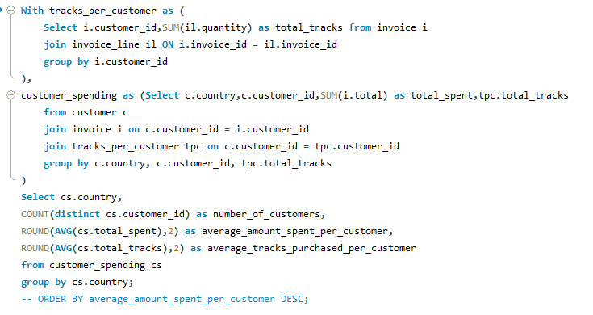  
3. Then I found the average of both the total amount spent and the total tracks purchased by the customer. 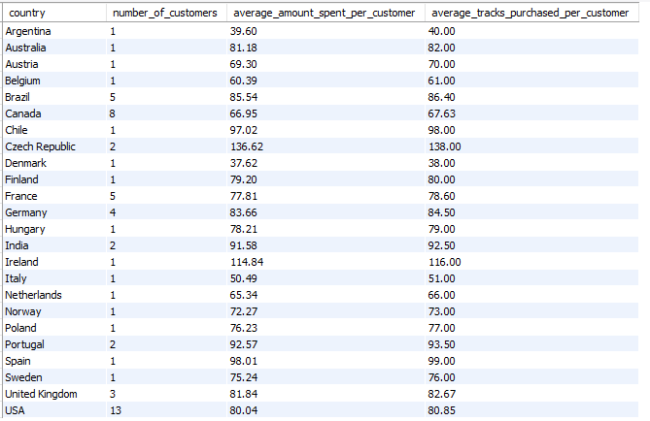

**Insights-** We see that the maximum number of customers are from the countries like the USA, Germany, France, Canada and Brazil with the average amount spent per customer and average tracks purchased per customer.   
